CONSULTATIVE WORKSHOP ON COMPETENCY BASED FRAMEWORK FOR SPECIAL EDUCATION TEACHER
FUNDED BY: AUSTRIAN DEVELOPMENT AGENCY (ADA)
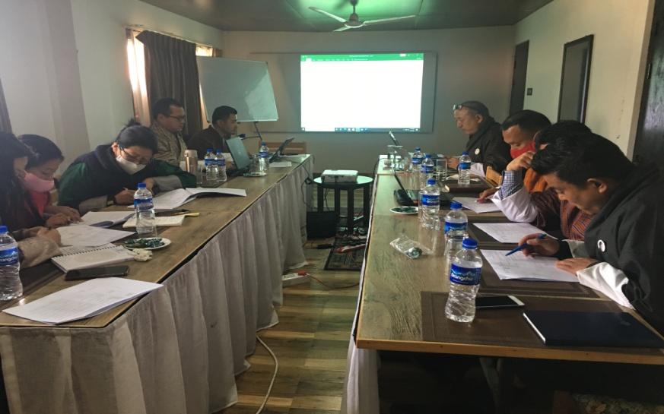
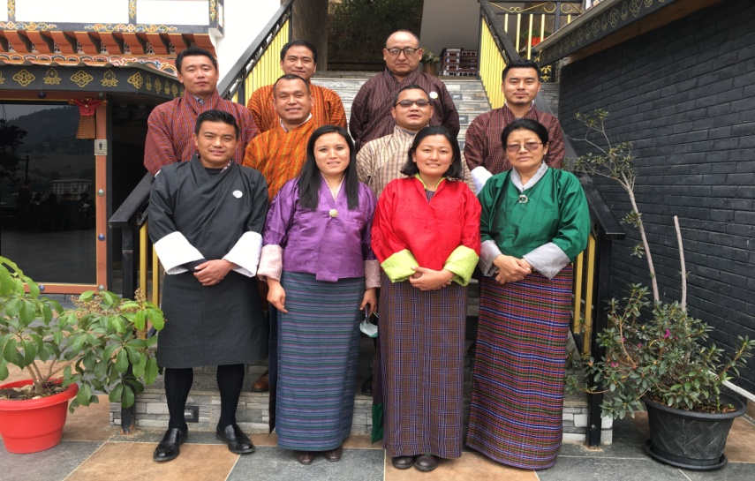
Under the “Competency-based HR Development Programme” of the Royal Civil Service Commission funded by the Austrian Development Agency (ADA), a Task Force team from Ministry of Education is conducting a 5 days consultative meeting for development of Competency-based Framework for Special Education Teachers in Punakha from 15-19 February 2021.
The Competency Based Framework (CBF) will help all Special Education Teachers to provide relevant Professional Development programmes as per the competency required which will be determined by this framework. This document will further help policy makers to plan and provide different interventions to the children with disabilities. The Special Education teachers from Wangsel Institute, Drukgyel LSS, Samtengang CS, Tshangkha CS, Damphu MSS and Changangkha MSS are participating in the 5 days consultative meeting for Competency Based Framework for Special Education Teachers.

