Guidelines for Re-opening of ECCD Centres
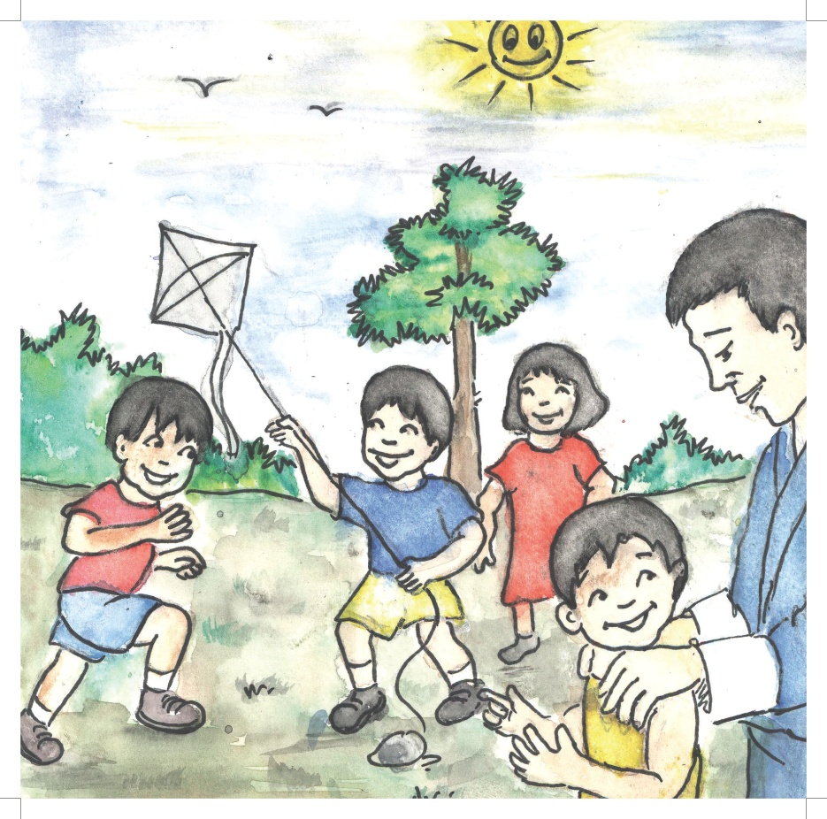
ECCD & SEN Division
Department of School Education
Ministry of Education
Thimphu
July 2020

Table of Content
Contents
1. Background 3
3. Preparedness for Re-opening 4
4. Requirements for Operation of ECCD Centres 5
4.1. Health, Hygiene and Safety Practices 6
4.2. Learning Environment and Curriculum Practices 7
4.3. Parent Support and Communication Practices 9
4.4. Staff Training and Support 10
5. Roles and Responsibilities 11
5.1. ECCD & SEN Division 11
5.2. Dzongkhag/ Thromde Education Office 11
5.3 Parent Schools 11
5.4 ECCD Centres and Facilitators 12
5.5 Parents/ Families 12
5.6 Children 12
6. Monitoring 12
7. Emergency Preparedness 13
Annexure A: Details of Private ECCD Centres 14
Annexure B : Checklist for Preparedness of ECCD Centres Re-opening 17

Background
It is a universally accepted fact that the early childhood period is the most critical and sensitive period for human development. During this time, the foundation for lifelong learning, good health, wholesome development and well-being are laid. On the other hand, quality ECCD services also contribute to returns on investment building quality human capital apart from immediate learning benefits in school. Thus, the Royal Government of Bhutan has accorded high priority to providing quality ECCD services which is evident from the investments made in centre based ECCD programmes and other related services such as the ‘The 1000 Golden Days’ initiative.
Currently, there are 495 ECCD centres including 51 Privately owned, 433 Government funded, 3 run by (NGO) Loden Foundation and 8 run by corporations spread across the Nation. The centers are facilitated by 948 ECCD facilitators out of which 192 are in private centres, 6 in NGO centres and 8 in corporation. Due to the COVID-19 pandemic, all schools and Institutions, along with ECCD centers across the nation have been closed from 18th March, 2020. This has deprived all our children from the wonderful opportunity to grow and develop to become healthy, happy and ready to learn child. In fact, our children could have suffered from increased vulnerability to stress, anxiety and abuse.
In the absence of active ECCD centre services, all the Facilitators made an effort to create opportunities for distance learning and home based interventions. However, high quality remote learning for ECCD children is not always as effective and feasible as online learning for older children in schools. This is because of the fact that learning and development for young children occurs primarily through active play and socialization which requires physical presence and interaction. Considering this, re-opening of ECCD Centres are critical.

Accordingly, the Office of the Honourable Prime Minister has directed that the centres be re-opened in a phased manner starting with Private ECCD centres. The details of private ECCD statistic are in the Annexure A.

However, considering the benefits of the centre programme to all children a staggered approach based on the urgency of circumstances will be adopted for reopening the community ECCD centres over time.

- Rationale
The following are the rationale for re-opening Private ECCD Centres:
- To resume face to face contact with children in their respective centres.
- Out of 9000 children 831children are enrolled in private ECCD centers covering 2.5% of the children between the ages 3-4 year old will be facilitated with the programme.
- Facilitate small families without other caregivers at home to return to office as the government discontinues work from home option especially for those in the urban areas.
- Help the Private ECCD proprietors to resume business and boost local economy.
- Resolve concerns of the families paying the fees for the private ECCD service.
- The Facilitators employed in the private ECCD centers can return to their work and not stay ideal at home.
- The movement of children will be confined between their homes and the ECCD centres only as parents will pick and drop off daily.

Preparedness for Re-opening
It has to be ensured that ECCD centres permitted to re-open in the aftermath of the COVID-19 crisis take precautionary health and safety measures and ensure adequate prepared to adapt to new norms and procedures so as to ensure safety and well-being of children, families and staff of the centres. In this sense, all ECCD centres need to fulfill the following requirements in order to re-open and also refer check list in Annexure B
- Facilitators and staff members of ECCD Centres should be oriented on health and safety guidelines issued by the Ministry of Health.
- ECCD Centres must have enough toilets for the children to ensure health and wellbeing.
- ECCD Centres must have one hand washing tap head for every group of 10 children to ensure hand hygiene and to mitigate risks of infection.
- ECCD centres must orient parents on the health and safety protocols to be followed by children.
- ECCD centres must have adequate room/ class, so as to ensure adequate space for social distancing as far as possible.
- ECCD classrooms must have adequate space to practice social distancing of at least 1 metre. Where ECCD centres do not meet this requirement, arrangements for expansion of space or measures to reduce the number of children must be put in place.
- Additional Facilitators must be recruited and deployed if additional space/ rooms are created to ensure that there is a minimum of one Facilitator for every group of 10 children.
- ECCD centres must adopt measures for shift or alternative systems if all of the above measures mentioned in sl. vi and vii are not feasible.
- ECCD centres must acquire and use thermal guns to screen the temperature of children, staff and visitors.
- ECCD centres must have disinfectants and sanitizers acquired before reopening.
- ECCD Centres must have paths and spaces marked for social distancing before reopening.
- All ECCD centres shall be physically assessed and certified by the DEO/TEO/Parent School Principal/ ECCD&SEN Division before being allowed to reopen to ensure that all of the above requirements are in place.

Requirements for Operation of ECCD Centres
In the process of re-opening, ECCD Centres certified to be ready for reopening and therefore permitted to reopen by the government should meet the following requirements in terms of day to day operation. Upon re-opening, all ECCD centres must observe and implement the following health, safety, well-being and development measures:

4.1. Health, Hygiene and Safety Practices
As ECCD centres are not reopening under normal circumstances, re-opening without precaution and safety measures involves imminent risks, which is why procedures and processes practiced in normal times are not enough for safe reopening of ECCD centres. Well prepared facilities with awareness of the circumstances and heightened caution must be put in place for safe and effective reopening of ECCD centres. Therefore, the following health, hygiene and feeding practices must be observed in all ECCD centres.
    - ECCD Centres must ensure regular cleaning of the ECCD classrooms and the whole premise.
    - Toilets must be cleaned and disinfected regularly.
    - Soaps, sanitizers and disinfectants are provided as required.
    - Frequently touched surfaces such as door handles, tables, toys, supplies, light switches, doorframes and play equipment used by children must besanitized and disinfected.
    - Staff members must wear face coverings within the ECCD Centre, if recommended by public health authorities.
    - Children must be taught COVID-19 prevention behavior including appropriate and frequent hand washing, coughing and sneezing manners and social distancing.
    - Regular hand washing must be encouraged and acknowledged.
    - Staff members must be educated on COVID-19 prevention behaviour including appropriate and frequent hand washing, coughing and sneezing manners and social distancing.
    - Schedule for frequent hand hygiene as a part of children’s and staff daily routine must be created and encouraged through posters and signage.
    - Air flow and ventilation in rooms must be enhanced to allow for healthy air circulation in rooms.
    - Trash must be removed daily and disposed of appropriately.
    - Compliance with food safety guidelines and proper hygiene must be enforced.
    - Meals and snacks are arranged in rooms with large space where social distancing is feasible.
    - Children must be reminded not to share or touch anyone else’s food, drinks, spoons, etc.
    - On arrival and departure, measurement of temperature must bead ministered for all with a non-contact thermometer, as well as whether they have respiratory symptoms or signs of other infectious diseases.
    - Children and Staff with increased body temperature, respiratory symptoms and other symptoms of infectious disease must be encouraged to stay at home and not come to the ECCD Centre.
    - Procedures to send home children and staff who become sick while at ECCD Centre must be established.
    - Other people, apart from parents picking up or dropping off children, should be prohibited or discouraged from entering or visiting the ECCD centre.

4.2. Learning Environment and Curriculum Practices
The re-opening of ECCD centres in the wake of the COVID-19 crisis calls for adaptation in the implementation of the curriculum and conduct of learning activities in order to practice public health instructions and precautionary measures as there are still imminent risks of infection and spread of the pandemic. Therefore, while it is beneficial to engage children in meaningful learning activities, it is also necessary to ensure that risks are minimized. As such, the following measures and adaptations should be considered in the process of conducting day to day activities in ECCD centres;
- Assessment of daily learning activities should be carried out to identify what can be done to minimize direct physical contact between children, keeping in mind developmental principles.
- Social distance of at least 1 metre between everyone present at the centres should be maintained.
- Breaks and outdoor times should be staggered so that smaller groups of children are outside or in the toilet at any given time.
- Children’s naptime mats should be spaced out as much as possible, depending on space available.
- Learning activities should be conducted outside as far as possible, weather permitting. (Young children love being outdoors, and it is safer for them to learn outside than inside at the moment).
- Indoor spaces should be set up for learning in a way that respects space between children while still makes it feel like a community – for example, designate sitting or standing spots using different materials like tape, circle spots, walking rope with handles, etc.
- Children should be split into smaller groups or 2-3 children to support interaction between children while limiting large group activity.
- Curriculum should be adapted and use of creative learning practices encouraged to ensure playful learning experiences around the pandemic situation (for example, project-based learning building on children’s experience with the pandemic; using imaginary play to help children cope with stress and promote resilience; using teachable moments to help children learn about the pandemic and their role in ensuring public health and safety).
- Individual learning activities should be balanced with small group interactions, using creativity to mix individual and group interactions.
- Toys and materials that are hard to sanitize or clean should not be used. Alternatively, children should be instructed to wash hands before and after their use.
- Children should also be reminded to avoid putting toys/materials in their mouths.
- Individual spaces should be designated for each child to store stationery that each child can use and to encourage continued creativity and art making without the need to share these between children.
- Imaginative play and physical games that respect social distancing should be encouraged.

4.3. Parent Support and Communication Practices
Families play an equally important role in ensuring safe and healthy practices in ECCD centres as children live between the home and the ECCD centres. What affects the home affects the ECCD centre and vice versa. Therefore, communication, coordination and collaboration between families and ECCD centres are critical to safe and effective operation of ECCD centres and safety of children.
    - Parents must be informed on the measures being put in place in the ECCD Centre, such as social distancing, staggered timings etc.
    - Parents must be consulted on the need to have one person identified to drop off and pick up children.
    - Parent are asked to not to let undesignated persons to drop off and pick up their child.
    - Parents must be consulted on drawing up a staggered drop off and pick up timing and procedure to avoid crowding and panic at these times.
    - Arrangements for staggering arrival and drop off times must be established and Facilitators to come outside to pick up the children as they arrive.
    - Parents must be asked to report if someone in their household is suspected to have COVID-19, and advised to keep the child home and inform the ECCD Centre.
    - Parents must be advised to keep children at home if they are not well.
    - Parents must be informed of the importance of measuring temperature for both themselves and children regularly.
    - Communication and coordination mechanisms that promote dialogue and engagement with parents regularly must be established by way of a social media group to alleviate stress, anxiety and ensure continuity for children between home and ECCD centre.

4.4. Staff Training and Support
The capacity and awareness of the Facilitators/ staff is important in ensure safe and effective operation of ECCD centres in uncertain times. Any shortcomings on their part in terms of their awareness, skills, attitudes and well-being could pose risks to the centre and jeopardize children’s safety and well-being. Therefore, it is important that Facilitators are equipped and prepared as follows:
- Facilitators are trained on health and safety guidelines of the Ministry of Health
- Facilitators are trained to practice and teach social distancing
- Facilitators are trained to screen children’s temperature using a thermal gun and maintain records.
- Facilitators are trained to practice and teach proper hand washing
- Facilitators are instructed to monitor their own health and the condition of children to adhere to procedures in accordance with the recommendations related to the prevention of COVID-19.
- Facilitators are supported to adapt the curriculum and daily routine of children effectively, including rethinking how learning activities and games can take place, how to utilize outdoor time, etc.
- Facilitators are trained to support socio-emotional needs of children in the COVID-19 situation through in-house trainings.
- Facilitators are equipped to deal with children’s mental health and psychosocial needs.
- Facilitators understand children are already unsettled and stressed and this transition initially will be hard and behavioral challenges are to be expected.
- Facilitators are trained to identify age-related behavioral and cognitive changes and provide age-appropriate learning support.

Roles and Responsibilities
In the process of re-opening and operation of ECCD Centres, it is necessary to delegate responsibilities to ensure effective implementation and monitoring of the health and safety measures. Hence, the roles and responsibilities are assigned as follows:

5.1. ECCD & SEN Division
- Develop Guidelines for Reopening ECCD Centres.
- Orient DEOs/TEOs on the implementation of the reopening guidelines
- Monitor implementation of the guidelines.
- Provide technical support for effective implementation of the guidelines
- Review implementation of the guidelines and incorporate changes in guidelines and protocols as required

5.2. Dzongkhag/ Thromde Education Office
- Orient Parent School Principals and ECCD Centres on the implementation of the reopening guidelines
- Monitor implementation of the guidelines and report to ECCD&SEN Division
- Provide technical support for effective implementation of the guidelines
- Review implementation of the guidelines within their jurisdiction and recommend changes in guidelines and protocols.

Parent Schools
- Orient ECCD Centre Managers and Facilitators on the implementation of the reopening guidelines
- Monitor implementation of the guidelines and report to DEO/ TEO
- Provide technical support for effective implementation of the guidelines
- Review implementation of the guidelines and recommend changes in guidelines and protocols as required.

ECCD Centres and Facilitators
- Prepare for re-opening of the ECCD Centres ensuring that all required facilities and measures are in place.
- Upon reopening, implement and observe all the measures and requirements placed by the Ministry of Education and Dzongkhag/Thromde Administration.
- Implement the guidelines and provide feedback on implementation and any emerging developments.

Parents/ Families
    - Ensure health and safety of one’s own child
    - Drop off and pick up own child at the time specified by the ECCD centre.
    - Help own child learn safe/healthy habits such as hand washing and social distancing.
    - Talk with the ECCD Centre Manager/Facilitators with what is going on in the centre.
    - Ensure the health and safety of oneself and one’s family.

Children
    - Attend ECCD centre
    - Learn and practice hand washing
    - Learn and practice social distancing
    - Not touch surfaces in public places and ECCD centre
    - Not share food, utensils and toys

Monitoring
- ECCD centres shall be consistently monitored for adherence to the requirements for operation.
- Parent School Focal Persons shall monitor ECCD centres and submit reports to DEOs/ TEOs
- DEOs/ TEOs shall monitor ECCD centres and share monitoring reports with the ECCD&SEN Division.
- The ECCD & SEND Division shall monitor and prepare the reports for the Ministry of Education

Emergency Preparedness
In the event of an outbreak or infection of COVID-19 in the community, ECCD centres shall adhere to emergency measures recommended by the Ministry of Health.

Annexure A: Details of Private ECCD Centres
Sl.# | Dzongkhag | ECCD Name | ECCD children enrollment |  | ECCD Facilitators
 |  |  | Gender | No of Children | Gender | No of ECCD Facilitator
1 | Bumthang | Jamyang Losel | Female | 12 | Female | 3
 |  |  | Male | 24 | Male | 0
2 |  | Ugyen Choling | Female | 2 | Female | 2
 |  |  | Male | 2 | Male | 0
3 | Gelephu Thromde | Gelephu Childcare | Female | 7 | Female | 6
 |  |  | Male | 6 | Male | 0
4 |  | Kuenrig Childcare | Female | 33 | Female | 5
 |  |  | Male | 21 | Male | 0
5 | Mongar | Little Kelkin's Green House | Female | 0 | Female | 3
 |  |  | Male | 0 | Male | 0
6 | Haa | Kuenphen | Female | 3 | Female | 1
 |  |  | Male | 7 | Male | 0
7 | Paro | Minsel | Female | 9 | Female | 2
 |  |  | Male | 10 | Male | 0
8 |  | Shaba , Zhungkhana | Female | 0 | Female | 1
 |  |  | Male | 0 | Male | 0
9 |  | Shari | Female | 23 | Female | 8
 |  |  | Male | 39 | Male | 0
10 |  | Thuksel | Female | 5 | Female | 1
 |  |  | Male | 4 | Male | 1
11 |  | Tshenden | Female | 7 | Female | 4
 |  |  | Male | 5 | Male | 1
12 |  | Yoezerling children's house | Female | 13 | Female | 3
 |  |  | Male | 7 | Male | 1
13 | Pema Gatshel | Denchi | Female | 8 | Female | 2
 |  |  | Male | 5 | Male | 0
14 |  | Phagma Jamtse | Female | 6 | Female | 2
 |  |  | Male | 11 | Male | 0
15 | Phuntsholing Thromde | First Step | Female | 0 | Female | 12
 |  |  | Male | 0 | Male | 0
16 |  | Khenphen | Female | 0 | Female | 4
 |  |  | Male | 0 | Male | 0
17 |  | Little Stars Daycare | Female | 0 | Female | 3
 |  |  | Male | 0 | Male | 0
18 |  | Mother Childcare | Female | 0 | Female | 8
 |  |  | Male | 0 | Male | 0
19 | Punakha | Kuenga | Female | 0 | Female | 1
 |  |  | Male | 0 | Male | 0
20 |  | Lekhar | Female | 6 | Female | 1
 |  |  | Male | 4 | Male | 0
21 |  | Namzang Day Care | Female | 0 | Female | 1
 |  |  | Male | 0 | Male | 0
22 | Samdrup Jongkhar | Motonga | Female | 18 | Female | 4
 |  |  | Male | 15 | Male | 0
23 |  | Tshunta Childcare | Female | 6 | Female | 1
 |  |  | Male | 7 | Male | 0
24 | Samtse | Samtse Childcare | Female | 11 | Female | 3
 |  |  | Male | 9 | Male | 1
25 | Sarpang | Tshering Childcare | Female | 4 | Female | 1
 |  |  | Male | 8 | Male | 0
26 | SJongkhar Thromde | Tashiphel | Female | 16 | Female | 2
 |  |  | Male | 10 | Male | 1
27 | Thimphu | Sonam Yangkhil, Kabesa | Female | 7 | Female | 1
 |  |  | Male | 8 | Male | 0
28 | Thimphu Thromde | Busy Bees Learning Center | Female | 25 | Female | 6
 |  |  | Male | 38 | Male | 0
29 |  | Dechencholing | Female | 6 | Female | 1
 |  |  | Male | 6 | Male | 0
30 |  | Druk Gunakara | Female | 13 | Female | 3
 |  |  | Male | 14 | Male | 0
31 |  | Goenkha Pangna / Changangkha | Female | 8 | Female | 5
 |  |  | Male | 2 | Male | 0
32 |  | Happy Feet | Female | 0 | Female | 6
 |  |  | Male | 0 | Male | 0
33 |  | Hejo | Female | 23 | Female | 7
 |  |  | Male | 33 | Male | 1
34 |  | Jamyang(Langophaka) | Female | 0 | Female | 3
 |  |  | Male | 0 | Male | 0
35 |  | Just Like Home | Female | 36 | Female | 7
 |  |  | Male | 28 | Male | 0
36 |  | Karma Norzoey Education Centre | Female | 8 | Female | 4
 |  |  | Male | 7 | Male | 0
37 |  | Kinder Care, Changjalu | Female | 0 | Female | 5
 |  |  | Male | 0 | Male | 0
38 |  | Lek_Yang | Female | 0 | Female | 4
 |  |  | Male | 0 | Male | 0
39 |  | Pelkyi Losel | Female | 12 | Female | 5
 |  |  | Male | 23 | Male | 0
40 |  | Play and learn | Female | 15 | Female | 10
 |  |  | Male | 14 | Male | 0
41 |  | Sersang Play group(motithang) | Female | 1 | Female | 3
 |  |  | Male |  | Male | 1
42 |  | Smiley Daycare | Female | 3 | Female | 3
 |  |  | Male | 7 | Male | 0
43 |  | Tiny Toes | Female | 0 | Female | 5
 |  |  | Male | 0 | Male | 0
44 |  | Wangmo Montessori | Female | 0 | Female | 8
 |  |  | Male | 0 | Male | 0
45 |  | Yontenling Starlets, Taba | Female | 16 | Female | 6
 |  |  | Male | 25 | Male | 0
46 | Trashigang | Timsina's Toddler Toes | Female | 3 | Female | 0
 |  |  | Male | 1 | Male | 1
47 | Trashiyangtse | Sonam Deki | Female | 1 | Female | 1
 |  |  | Male | 5 | Male | 0
48 | Tsirang | Lamsyel | Female | 0 | Female | 2
 |  |  | Male | 0 | Male | 0
49 | Wangdue Phodrang | Blossom Kindergarten | Female | 21 | Female | 3
 |  |  | Male | 23 | Male | 1
50 |  | Kids R Kids | Female | 3 | Female | 4
 |  |  | Male | 1 | Male | 0
51 |  | Tiny Sprout Child Care | Female | 5 | Female | 1
 |  |  | Male | 7 | Male | 0
 | Total |  |  | 831 |  | 196

Annexure B : Checklist for Preparedness of ECCD Centres Re-opening
 | The assessment of ECCD Centres prior to reopening is to ensure that centres take precautionary health and safety measures to ensure adequate preparedness to adapt to new norms and procedures for the safety and well being of children, families and staff of the centres.
 | Name of ECCD Centre:………….. | No of Facilitators:… | No of Children: Boys ( ). Girls: ( ). Tot:
Sl# | Particulars | Current State | Action Recommended | Deadline for Rectification
1 | Facilitators and staff members of ECCD Centres are awareof health and safety guidelines issued by the Ministry of Health
2 | The ECCD Centre has one toilet for every group of 10 children to ensure adequate space for social distancing.
3 | The ECCD Centre has one hand washing tap head for every group of 10 children to ensure hand hygiene and to mitigate risks of infection.
4 | The ECCD centre has developed health and safety protocols and has comprehensive plan to ensure safety and well being of children when the centre reopens.
5 | The ECCD Centre has oriented parents on health and safety protocols to be followed by children.
6 | The ECCD Centre has enough space to ensure that no more than 10 children will be accommodated in any particular room, so as to ensure adequate space for social distancing is possible.
7 | The ECCD classrooms have adequate space for the number of children enrolled to practice social distancing of at least 1 metre. If the centre does not meet this requirement, arrangements for expansion of space or measures to reduce the number of children must be put in place.
8 | Additional Facilitators have been recruited and deployed if additional space/ rooms created to ensure that there is a minimum of one Facilitator for every group of 10 children.
9 | The ECCD Centre has adopted measures for shift or alternative systems where all of the above measures are not feasible.
10 | The ECCD Centre has acquired thermal scanner to screen the temperature of children, staff and visitors.
11 | The ECCD Centre has acquired disinfectants and sanitizers before reopening.
12 | The ECCD Centre has paths and spaces marked to enable social distancing before reopening.
13 | The ECCD centres is prepared to reopen

